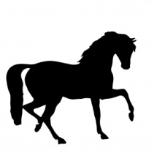 Sunbury Animal Hospital
Trail Ride for the American Cancer Society
Ride Date: Saturday, May 4, 2019
Time: Ride leaves the campsite at 1 pm.
Site: Hall Mountain Camping Area – see map
Trail Boss: Kim Clemens
Contact: Sunbury Animal Hospital Reception Desk (570) 286-5131.
Please RSVP by April 26 so we know how many riders to expect.
To Participate:
- Call the Sunbury Animal hospital to register. Please leave a home or cell number where you can be reached in case of inclement weather. If you are a part of a group, please report the number of riders accompanying you. Invite your friends!
- Sign and date the attached waiver. A waiver must be turned in at the trail ride for each rider. Riders under the age of 18 must have the form signed by a parent or guardian.
- Ask your family and friends to sponsor your ride (see the attached sheet). The sponsor sheet will be turned in at the ride along with your payment. The more sponsors you have, the greater the benefit to the American Cancer Society.
- A minimum of $30 in sponsorship is requested for each rider. Please turn in your sponsor money in the form of checks made out to the American Cancer Society. We would prefer checks to cash payment.
- Wear comfortable clothes appropriate for the weather. The ride will be held rain or shine unless the weather is too severe. If the ride is to be cancelled, we will call all registered riders with notification.
- We offer a short ride (approximately 2 hours) and a longer ride (3 hours).
- We recommend that horses be shod or be wearing boots.
- There is no running water at the campsite, so please bring water for your horses.
- A picnic lunch will be provided after the ride. If possible, bring a dish to share.
Safety tips:
- Owners of horses that kick are asked to tie a red ribbon on their animal’s tail.
- Check all riding gear and equipment for safety prior to the ride.
- A helmet is recommended for all riders.

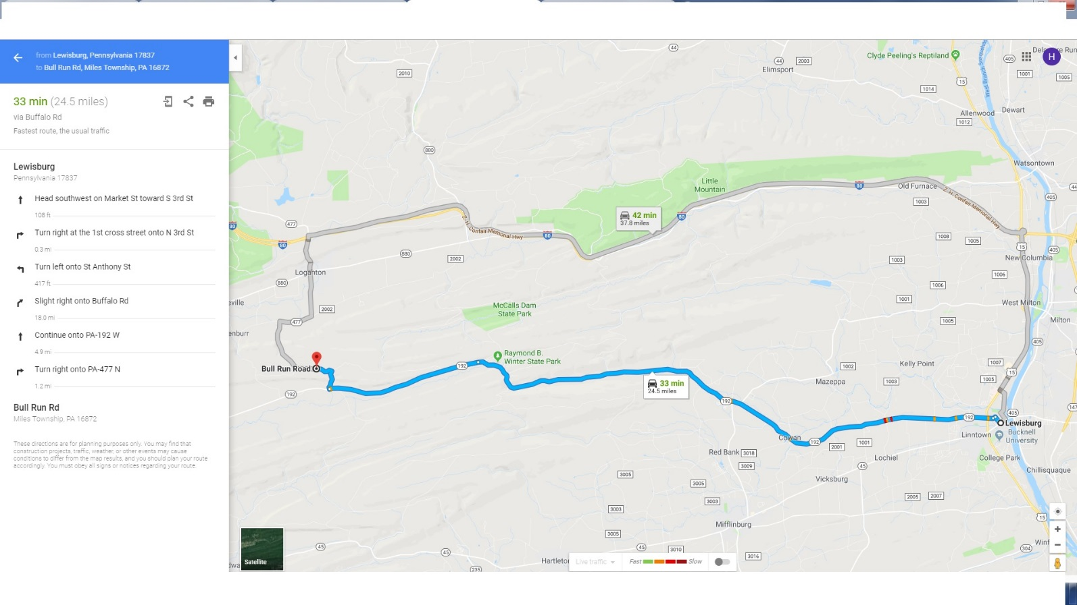

We will offer both a short and a long ride. All riders will go out together on wooded trails and dirt roads. After approximately one hour, any riders who choose to turn around will be guided back to the campsite. The remainder of the riders will continue for a ride lasting approximately 3 hours. The longer ride crosses a small stream and has a rocky section and a hill. Horseshoes or boots are recommended for horses with sensitive feet.

